**KINGSTON ENGINEERING COLLEGE-5113**

**ARTIFICIAL INTELLIGENCE - PHASE 3**

**TOPIC: PREDICTING HOUSE PRICES USING MACHINE LEARNING**

**TEAM MEMBERS:**

**V. EBONICA SALETH- au511321104025(**[**ebonicasalethvincent@gmail.com**](mailto:ebonicasalethvincent@gmail.com)**)**

**G. KANIMOZHI- au511321104040(** [**kanimozhigopalgopal2004@gmail.com**](mailto:kanimozhigopalgopal2004@gmail.com)**)**

**D. AKSHAYA- au511321104004(**[**Akshayadayalan03@gmail.com**](mailto:Akshayadayalan03@gmail.com)**)**

**K. INDUJA-**

**au511321104031(**[**indujaindu137@gmail.com**](mailto:indujaindu137@gmail.com)**)**

**CONTENT:**

* PYTHON CODE WITH OUTPUT CREATED WITH GOOGLE COLABORATORY
* CODE EXPLANATION:

1. IMPORTING LIBRARIES

2. LOADING THE GIVEN DATASET

3. READING THE GIVEN DATASET

4. DATA EXPLORATION

5. SPLITTING THE DATASET INTO FEATURES (X) AND TARGET VARIABLE (y)

6. PREPROCESSING THE DATASET USING MINMAX SCALER

7. EXCLUDING THE ADDRESS COLUMN

8. SPLITTING THE DATASET INTO TRAINING AND TESTING SETS

9. SAVING THE TRAIN AND TEST DATASETS

10. PREPROCESSING THE DATASET USING STANDARD SCALER

11. CROSS-VALIDATION WITH DIFFERENT PREPROCESSING METHODS AND ALGORITHMS

12. BUILDING THE MODELS

**LIBRARIES USED:**

* Pandas
* Sklearn
* Numpy

**DATASET DETAILS:**

We will acquire our dataset from Kaggle, specifically the "USA Housing" dataset. This dataset will contain a wealth of information about houses in the USA, making it suitable for our predictive modeling task.

**KAGGLE DATASET:**

**LINK:** <https://www.kaggle.com/datasets/vedavyasv/usa-housing>

**PREDICTING HOUSE PRICES USING MACHINE LEARNING**

AI_Phase3(EBONICA SALETH).ipynb

**Original file is located at:**

<https://colab.research.google.com/drive/19M4Q4pktG_NLaIVcl25Ibd3xMRCpuccM>

**PYTHON CODE WITH OUTPUT CREATED WITH GOOGLE COLAB:**

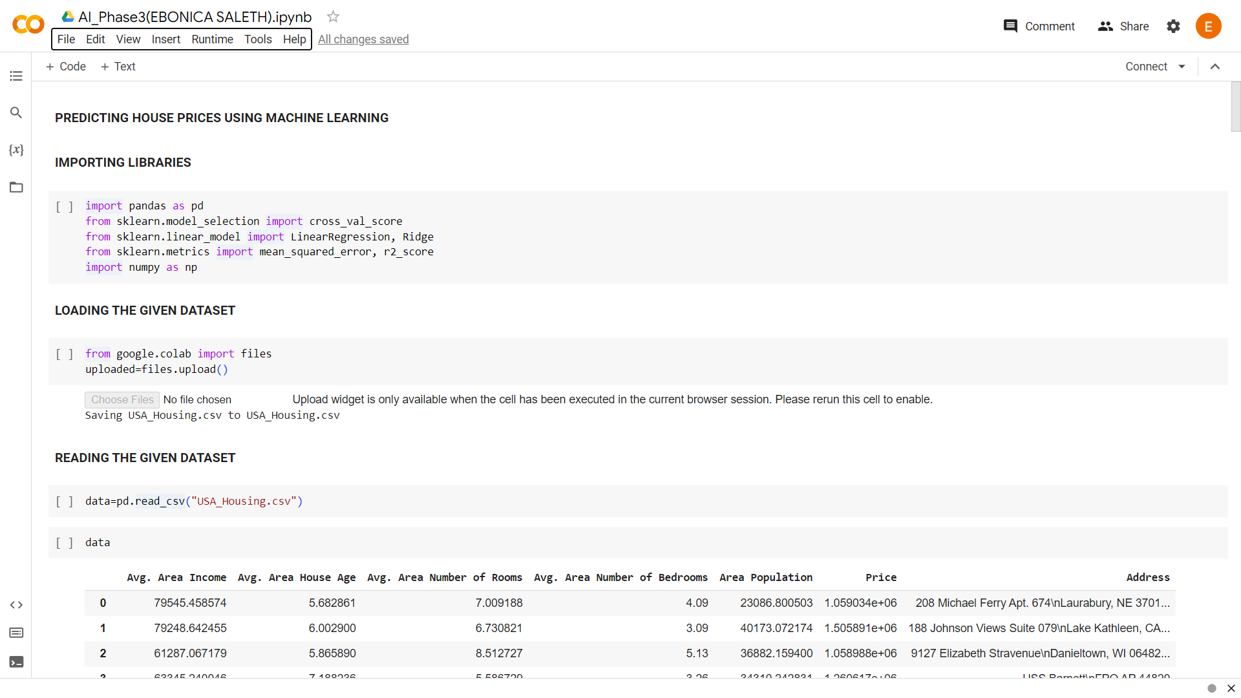

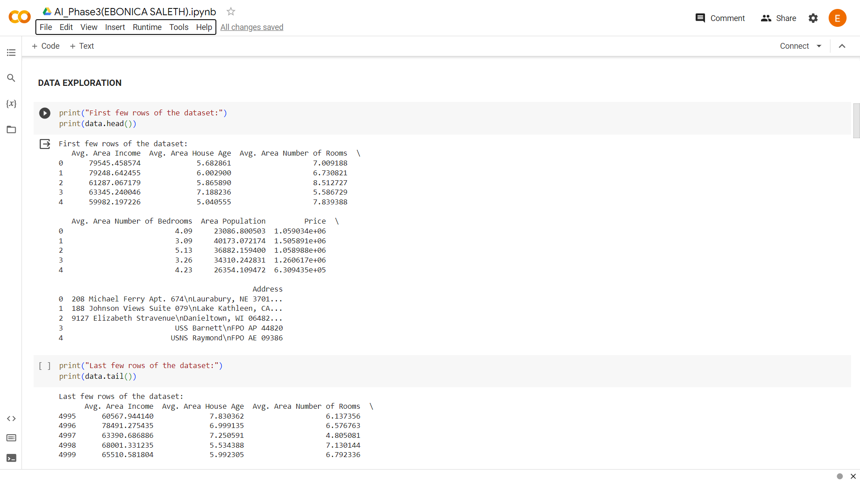

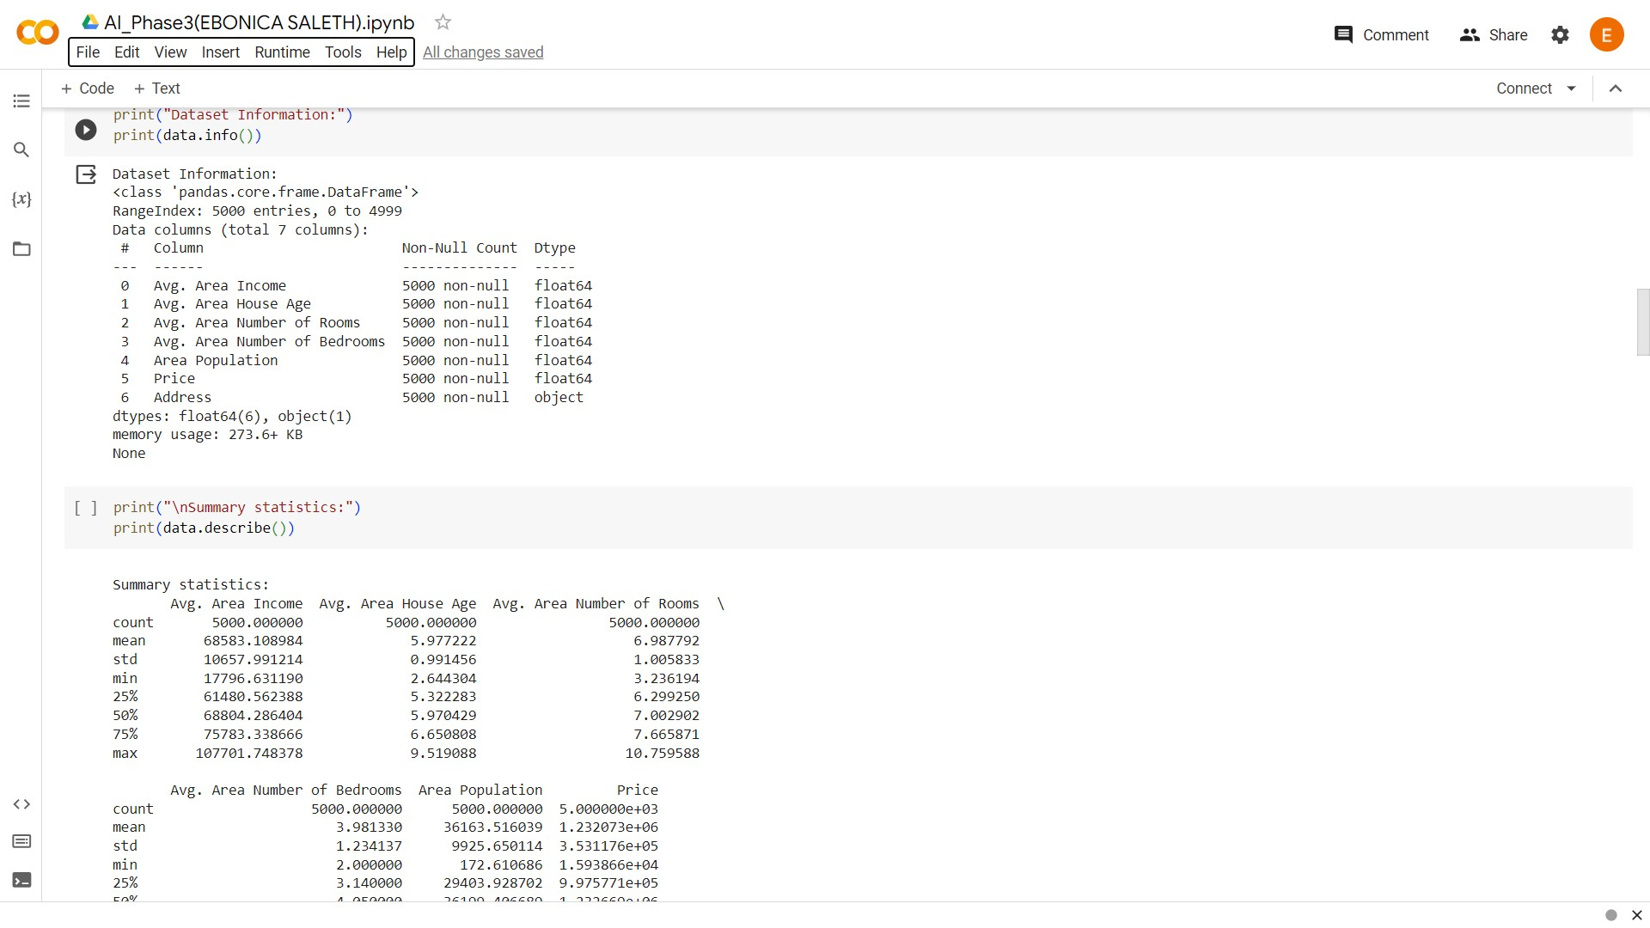

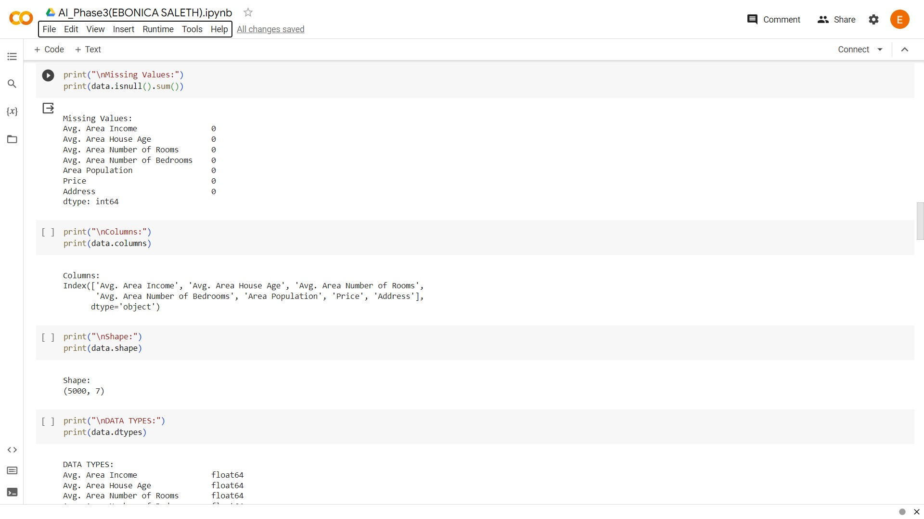

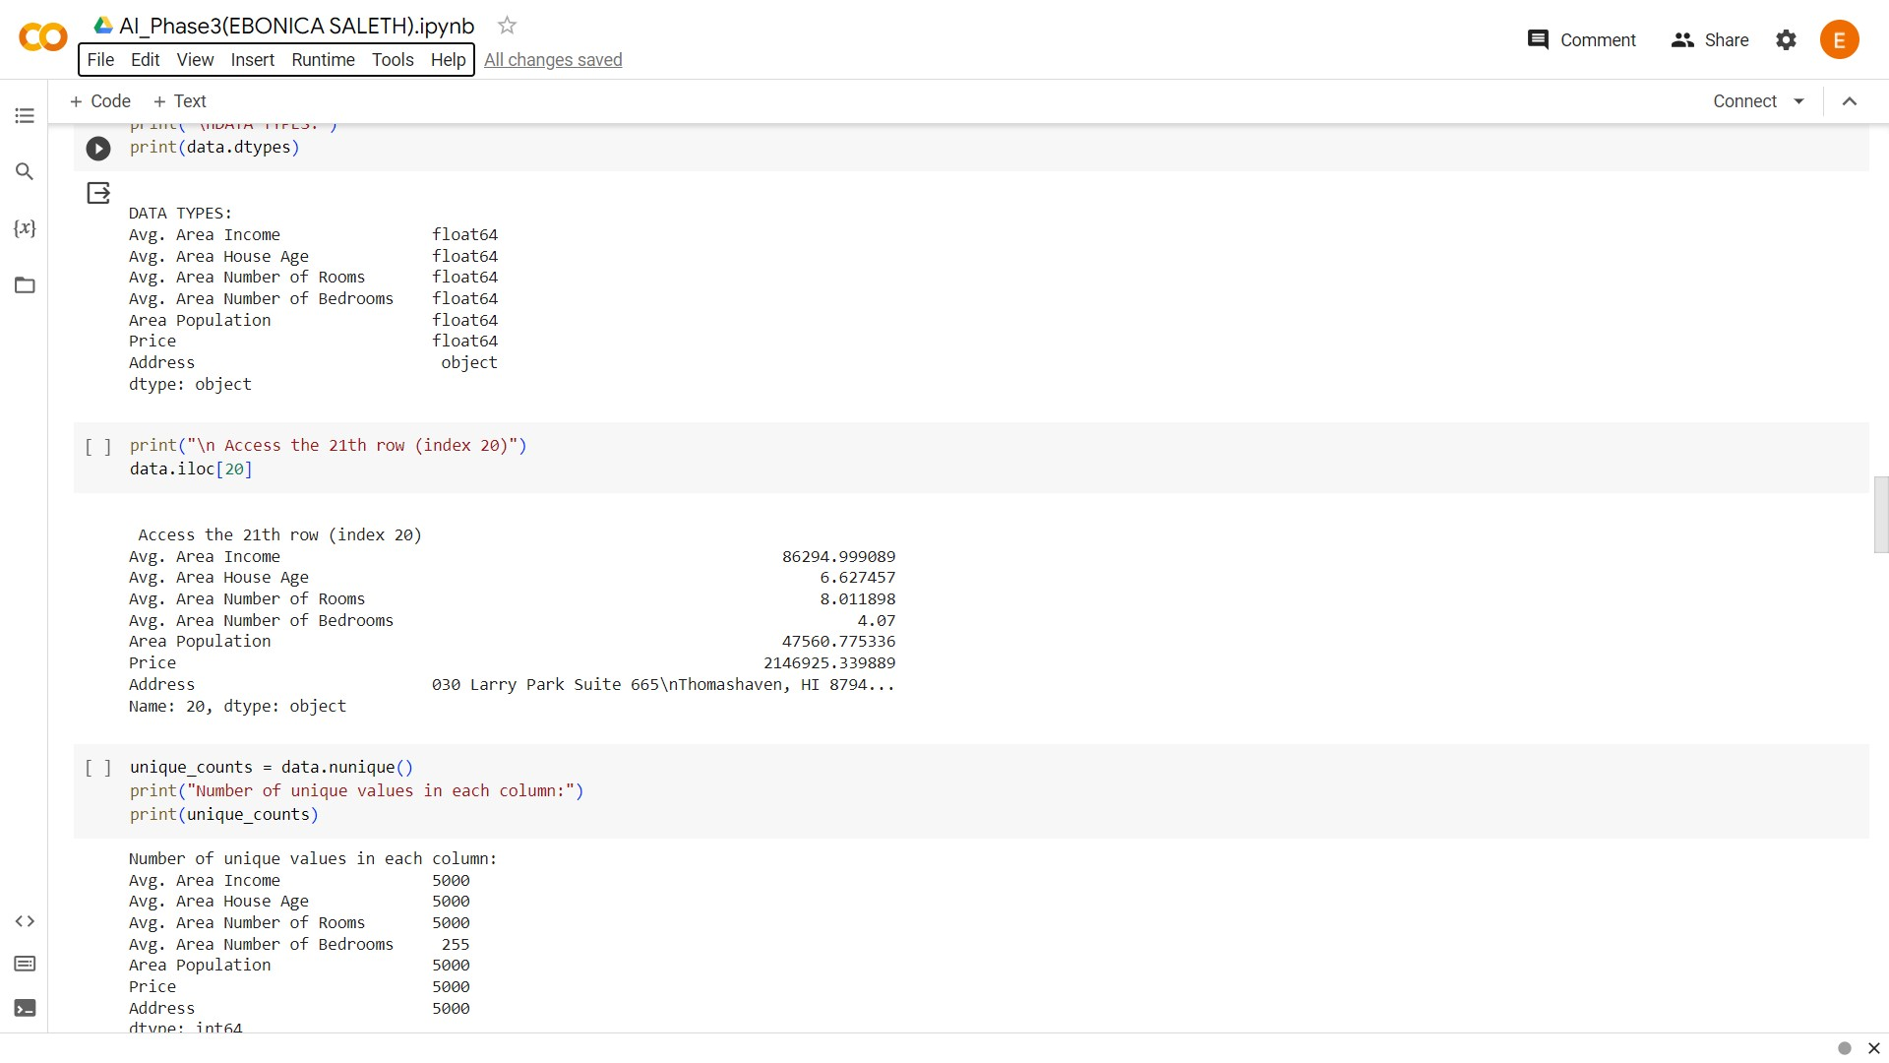

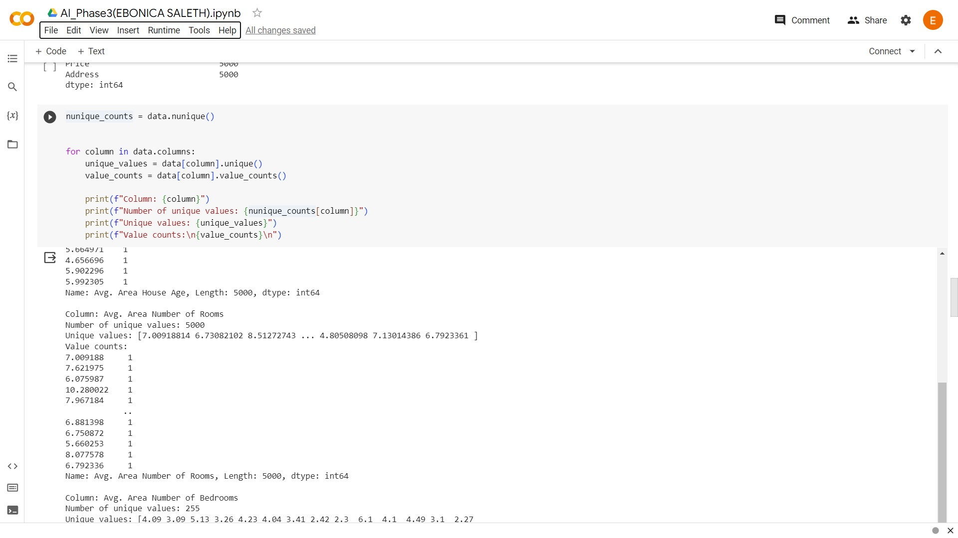

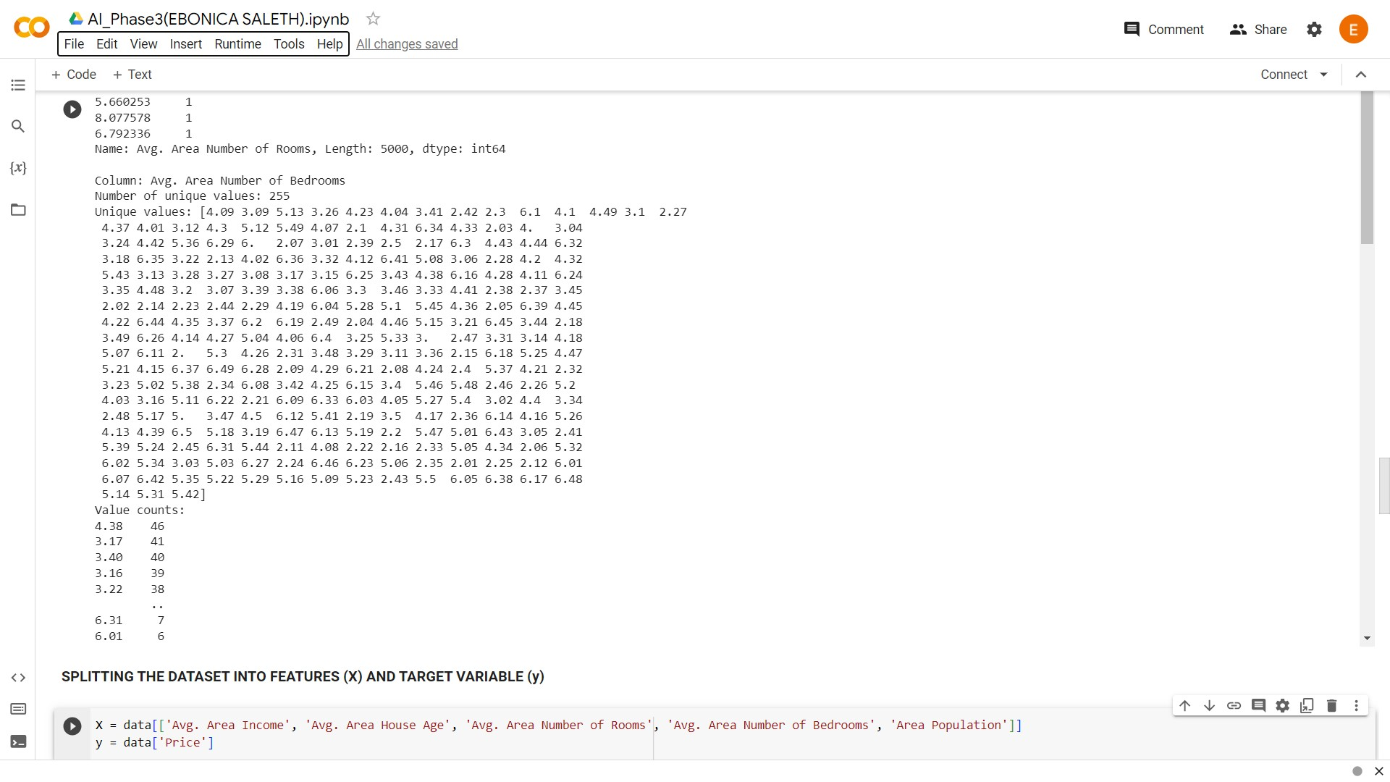

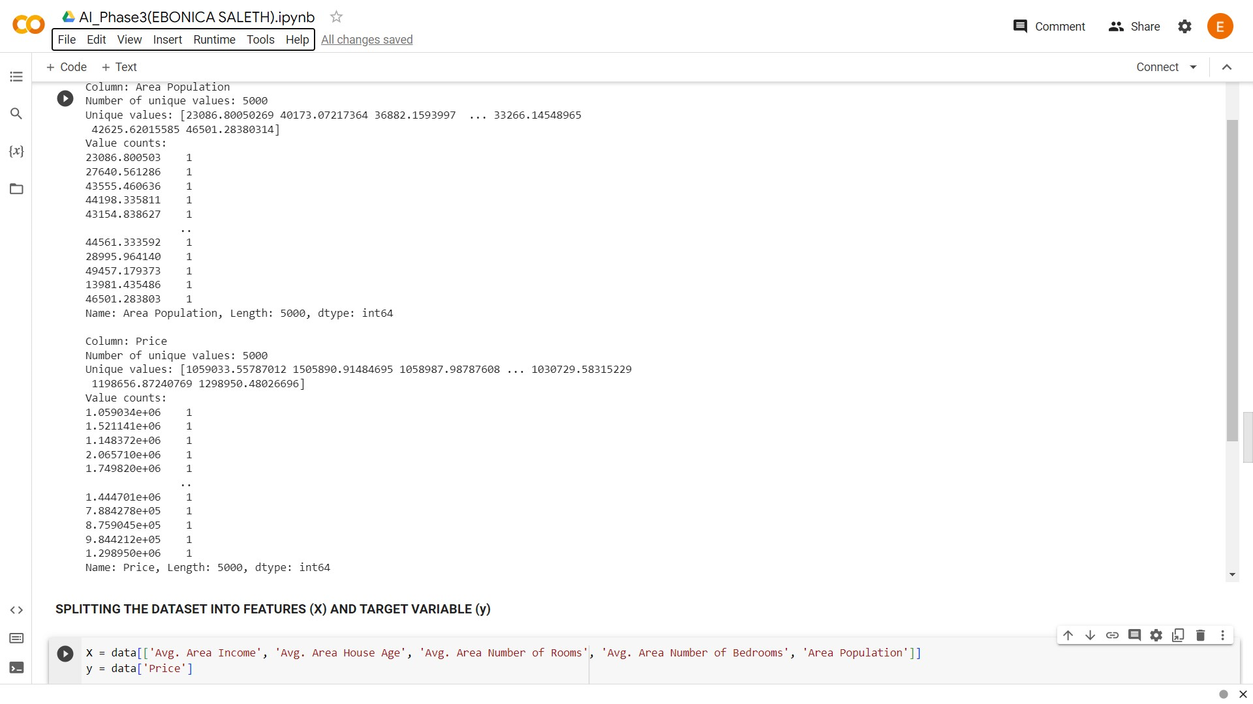

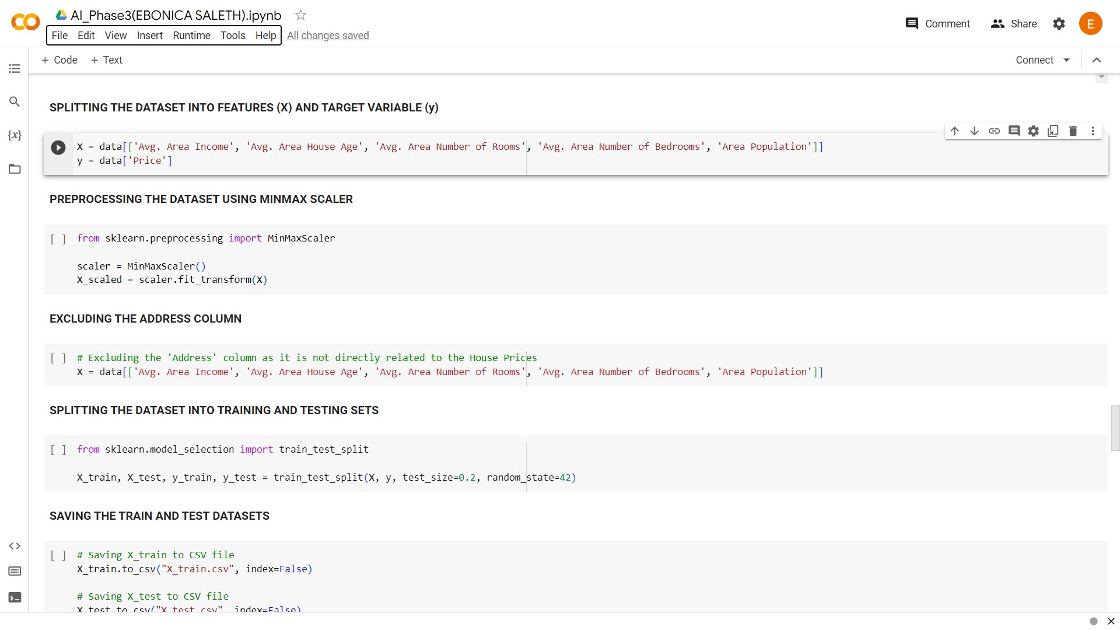

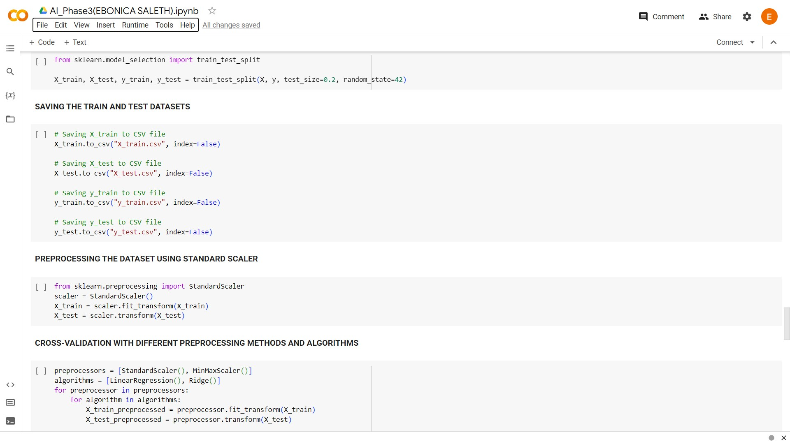

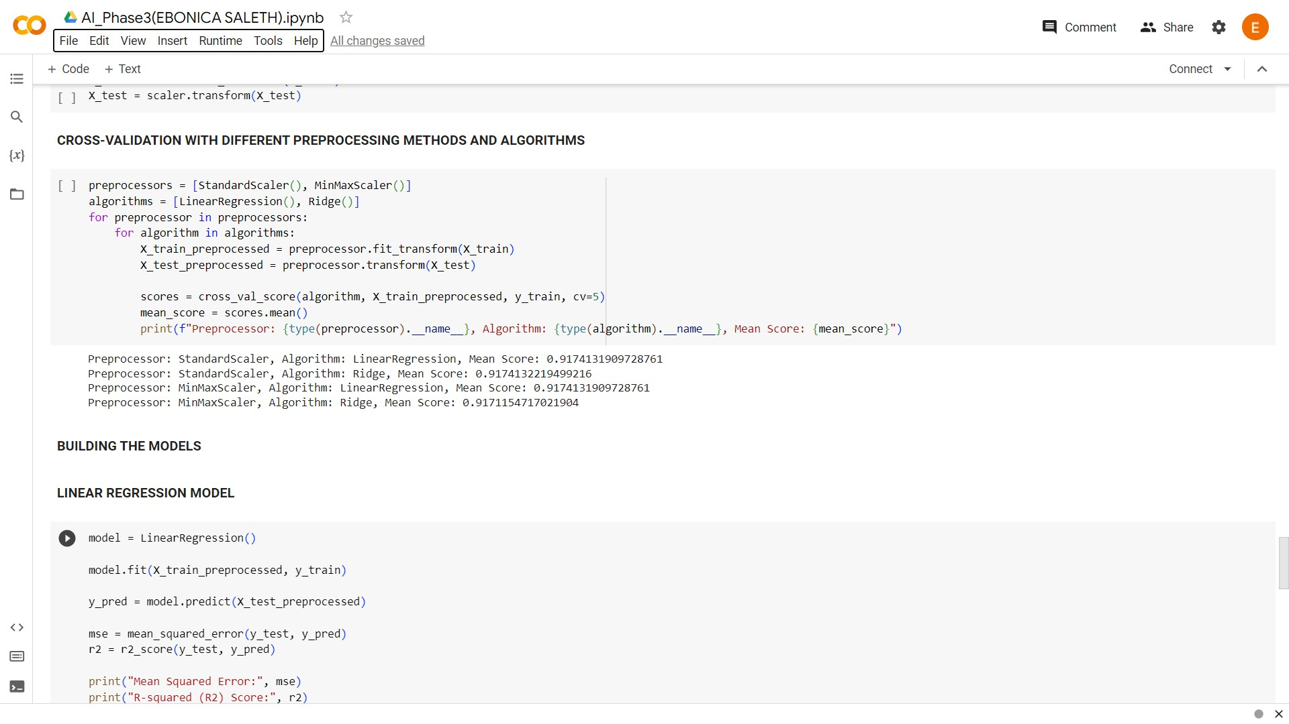

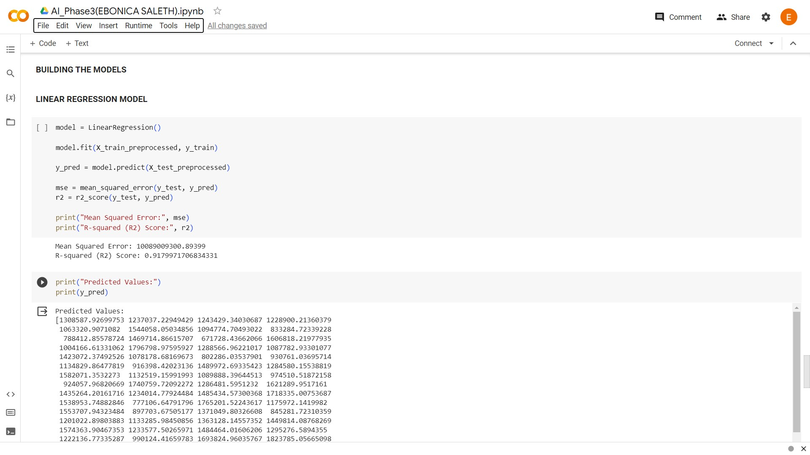

**CODE EXPLANATION:**

**IMPORTING LIBRARIES:**

In this section, the necessary Python libraries are imported to perform various tasks in building a house price prediction model. These libraries include pandas for data handling, scikit-learn for machine learning, and NumPy for numerical operations.

**CODE:**

import pandas as pd

from sklearn.model_selection import cross_val_score

from sklearn.linear_model import LinearRegression, Ridge

from sklearn.metrics import mean_squared_error, r2_score

import numpy as np

**LOADING THE GIVEN DATASET:**

The provided dataset is loaded into the environment using Google Colab's file upload feature.

**CODE:**

from google.colab import files

uploaded = files.upload()

**READING THE GIVEN DATASET:**

The dataset is read into a pandas dataframe ('data') for further analysis and modeling.

**CODE:**

data = pd.read_csv("USA_Housing.csv")

**DATA EXPLORATION:**

This section is dedicated to exploring the dataset to gain insights into its structure and content. Various operations are performed, including displaying the first and last few rows, dataset information, summary statistics, missing values, columns, shape, data types, accessing a specific row, and calculating the number of unique values in each column.

**CODE:**

# Display the first and last few rows of the dataset

print(data.head())

print(data.tail())

# Display dataset information

print(data.info())

# Display summary statistics

print(data.describe())

# Check for missing values

print(data.isnull().sum())

# List the columns

print(data.columns)

# Get the shape of the dataset

print(data.shape)

# Display data types of columns

print(data.dtypes)

# Access the 21st row (index 20)

data.iloc[20]

# Calculate the number of unique values in each column

unique_counts = data.nunique()

**SPLITTING THE DATASET INTO FEATURES (X) AND TARGET VARIABLE (y)**

The dataset is divided into two parts: the feature matrix ('X') and the target variable ('y'). In this case, the selected features include 'Avg. Area Income,' 'Avg. Area House Age,' 'Avg. Area Number of Rooms,' 'Avg. Area Number of Bedrooms,' and 'Area Population,' while the target variable is 'Price.'

**CODE:**

X = data[['Avg. Area Income', 'Avg. Area House Age', 'Avg. Area Number of Rooms', 'Avg. Area Number of Bedrooms', 'Area Population']]

y = data['Price']

**PREPROCESSING THE DATASET USING MINMAX SCALER**

The MinMaxScaler is applied to the feature matrix 'X' to scale the values within the range [0, 1].

**CODE:**

from sklearn.preprocessing import MinMaxScaler

scaler = MinMaxScaler()

X_scaled = scaler.fit_transform(X)

**EXCLUDING THE ADDRESS COLUMN**

The 'Address' column is excluded from the feature matrix 'X' since it is not directly related to house prices.

**CODE:**

X = data[['Avg. Area Income', 'Avg. Area House Age', 'Avg. Area Number of Rooms', 'Avg. Area Number of Bedrooms', 'Area Population']]

**SPLITTING THE DATASET INTO TRAINING AND TESTING SETS**

The dataset is divided into training and testing sets using an 80-20 split ratio. The 'X_train' and 'X_test' datasets are created for features, and 'y_train' and 'y_test' for the target variable.

**CODE:**

from sklearn.model_selection import train_test_split

X_train, X_test, y_train, y_test = train_test_split(X, y, test_size=0.2, random_state=42)

**SAVING THE TRAIN AND TEST DATASETS**

The training and testing datasets are saved as CSV files for future use.

**CODE:**

X_train.to_csv("X_train.csv", index=False)

X_test.to_csv("X_test.csv", index=False)

y_train.to_csv("y_train.csv", index=False)

y_test.to_csv("y_test.csv", index=False)

**PREPROCESSING THE DATASET USING STANDARD SCALER**

The StandardScaler is applied to standardize the training and testing datasets.

**CODE:**

from sklearn.preprocessing import StandardScaler

scaler = StandardScaler()

X_train = scaler.fit_transform(X_train)

X_test = scaler.transform(X_test)

**CROSS-VALIDATION WITH DIFFERENT PREPROCESSING METHODS AND ALGORITHMS**

Cross-validation is performed using different preprocessing methods (StandardScaler and MinMaxScaler) and algorithms (LinearRegression and Ridge). The code calculates the mean score for each combination.

**CODE:**

preprocessors = [StandardScaler(), MinMaxScaler()]

algorithms = [LinearRegression(), Ridge()]

for preprocessor in preprocessors:

for algorithm in algorithms:

X_train_preprocessed = preprocessor.fit_transform(X_train)

X_test_preprocessed = preprocessor.transform(X_test)

scores = cross_val_score(algorithm, X_train_preprocessed, y_train, cv=5)

mean_score = scores.mean()

print(f"Preprocessor: {type(preprocessor).__name__}, Algorithm: {type(algorithm).__name__}, Mean Score: {mean_score}")

**BUILDING THE MODELS**

The code trains a Linear Regression model on the preprocessed training data and evaluates its performance on the testing data. It calculates and displays the Mean Squared Error (MSE) and R-squared (R2) Score as evaluation metrics for the Linear Regression model. The predicted values are also printed.

**CODE:**

model = LinearRegression()

model.fit(X_train_preprocessed, y_train)

y_pred = model.predict(X_test_preprocessed)

mse = mean_squared_error(y_test, y_pred)

r2 = r2_score(y_test, y_pred)

print("Mean Squared Error:", mse)

print("R-squared (R2) Score:", r2)

print("Predicted Values:")

print(y_pred)

**CONCLUSION:**

This code illustrates a house price prediction model using Linear Regression, and it includes data exploration, preprocessing, model building, and evaluation. Further enhancement of the model and analysis will be done in Phase 4.